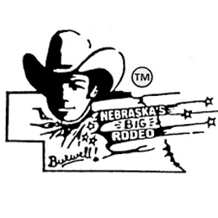
NEBRASKA’S BIG RODEOTM
Wild Horse Race
Official Entry Form
$6,000 added money
Ground Rules
- Horses will be drawn immediately following the National Anthem (south Concession Stand).
- Buckles will be given to the First Place Team.
- Contestants must have their own equipment. (Rope, saddle, etc.)
- A qualified ride will be when crossing the finish line at the red pole after a full lap around the track.
- In the event of a tie, the winner will be decided by the wild ride.
- There will be four rounds and average.
- Contestants must have completed waiver submitted prior to the first performance. (Information Booth)
- Entries close Wednesday night prior to the first performance.

Team Name___________________________________________________________________
Team Member Names __________________________________________________________
_____________________________________________________________________________
Address_________________________________________________ City_______________ State_____ Zip__________
Phone Number_________________________________
Email Address___________________________________________________

Send entry form, along with $400 entry fee made out to Nebraska’s Big RodeoTM to the following address:
Nebraska’s Big Rodeo
Attn: Wild Horse Race
P.O. Box 711
Burwell, NE 68823

____________________________________________
Team Representative Signature

