NEBRASKA’S BIG RODEOTM
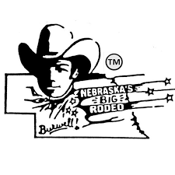
DINNER BELL DERBY
OFFICIAL ENTRY FORM
JULY 24-27, 2024
$40 Entry Fee (Two Rodeo Passes Per Entry)
$1,000 Added Money and Entry Fee Payback

Foals Name: ______________________________________________________________________
Sex: ________Birth Date: ________________
Owner: ____________________________________________________________________________
Address: __________________________________________________________________________
City: ___________________________State:__________________Zip:_______________________
Phone Number:_________________________________________________________
I, the undersigned, agree that the Garfield County Frontier Fair Association/Nebraska’s Big Rodeo TM, will not be held responsible for any accident or injury to my animals, myself, or any person helping me with the race.
Signature:_____________________________________________________Date:_____________________
Parents or Guardians must sign for minors.
_____________________________________________________________________________________________
Send Entry form and entry fee to:
Nebraska’s Big Rodeo
Attn: Dinner Bell Derby
P.O. Box 711
Burwell, NE 68823

