NEBRASKA’S BIG RODEOTM
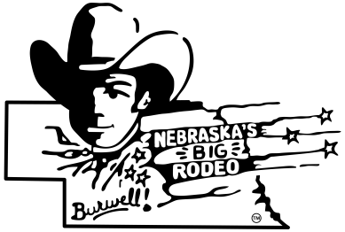
DINNER BELL DERBY RULES

1. The Dinner Bell Derby is not sanctioned by any organization.

2. Completed and signed entry blank and entry fee must be submitted by entry deadline.

3. Entry fees and added purse will be paid back to winners.

4. Each entry will receive two rodeo passes.

5. Only one person per horse will be allowed on the track.

6. There will be a designated starting and finish line.

7. There will be a designated line, past the finish line, where the mares must be kept.

8. Foals leaving the starting line before the official start will be disqualified.

9. Judges decision will be final.

10. Failure to adhere to the rules or rowdy conduct may result in a disqualification.

11. It will be your responsibility to read and understand the rules.

12. Checks will be mailed after the rodeo is over.

13. All participants will wear western attire. Western attire includes long sleeved western shirt and a cowboy hat. Only those with long sleeves and a hat will be allowed on the track. Rodeo board WILL enforce PRCA rules.

14. Enter as soon as possible. Any entries received after we reach our quota, will be returned.

15. Stalls are available. Please use stalls in the horse barns in the southwest corner of the grounds.

16. Winners are determined by the foal crossing the finish line.

17. Please make checks payable to Nebraska’s Big RodeoTM.

18. Be sure your mares and foals are in the derby waiting area in ample time. We have to go on schedule---so be ready.
THANK YOU!!

