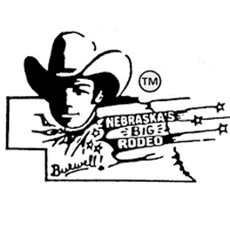**NEBRASKA’S BIG RODEOTM**

**Wild Horse Race**

**Official Entry Form**

**$6,000 added money**

**Ground Rules**

* Horses will be drawn immediately following the National Anthem (south Concession Stand).
* Buckles will be given to the First Place Team.
* Contestants must have their own equipment. (Rope, saddle, etc.)
* A qualified ride will be when crossing the finish line at the red pole after a full lap around the track.
* In the event of a tie, the winner will be decided by the wild ride.
* There will be four rounds and average.
* Contestants must have completed waiver submitted prior to the first performance. (Information Booth)
* Entries close Wednesday night prior to the first performance.

Team Name___________________________________________________________________

Team Member Names __________________________________________________________

_____________________________________________________________________________

Address_________________________________________________ City_______________ State_____ Zip__________

Phone Number_________________________________

Email Address___________________________________________________

Send entry form, along with $400 entry fee made out to Nebraska’s Big RodeoTM to the following address:

Nebraska’s Big Rodeo

Attn: Wild Horse Race

P.O. Box 711

Burwell, NE 68823

____________________________________________

Team Representative Signature