NEBRASKA’S BIG RODEOTM

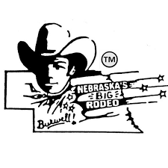

DINNER BELL DERBY

OFFICIAL ENTRY FORM

$40 Entry Fee (Two Rodeo Passes Per Entry)

$1,000 Added Money and Entry Fee Payback

**_____________________________________________________________________________________________**

Foals Name: ______________________________________________________________________

Sex: ________Birth Date: ________________

Owner: ____________________________________________________________________________

Address: __________________________________________________________________________

City: ___________________________State:__________________Zip:_______________________

Phone Number: ___________________________________________________________________

I, the undersigned, agree that the Garfield County Frontier Fair Association/Nebraska’s Big Rodeo TM, will not be held responsible for any accident or injury to my animals, myself, or any person helping me with the race.

Signature:_______________________________________________Date:_____________________

Parents or Guardians must sign for minors.

_____________________________________________________________________________________________

Send Entry form and entry fee to:

Nebraska’s Big Rodeo

Attn: Dinner Bell Derby

P.O. Box 711

Burwell, NE 68823